Golden_Gate with ORM stack

Contents

1. Introduction 3
2. Workflow diagram to deploy the stack 3
3. Create stack for Golden gate 4
4. Plan the Job 6

Introduction

GoldenGate is a fully managed service that helps data engineers move data in real-time, at scale, from one or more data management systems to Oracle Cloud databases. Design, run, orchestrate, and monitor data replication tasks in a single interface without having to allocate or manage any compute environments.

Workflow diagram to deploy the stack

Below diagram shows how the Terraform Artifact are applied in the OCI. While creating a ORM stack, using terraform deliverables Init, Plan and Apply is the flow to provision the resource in the OCI. We can have the deliverables in any of below.

- GitLab/GitHub Repo
- Bitbucket
- Can be in folder/.zip in the local disk
- Object Storage Bucket
- Can be in compartment
- Oracle provided Template


Create stack for Golden gate

Go to OCI Console Developer Services Resource Manager Stacks select the compartment Create Stack

My Configuration Folder Browse Select the “golden_gate” folder that contains the terraform Upload

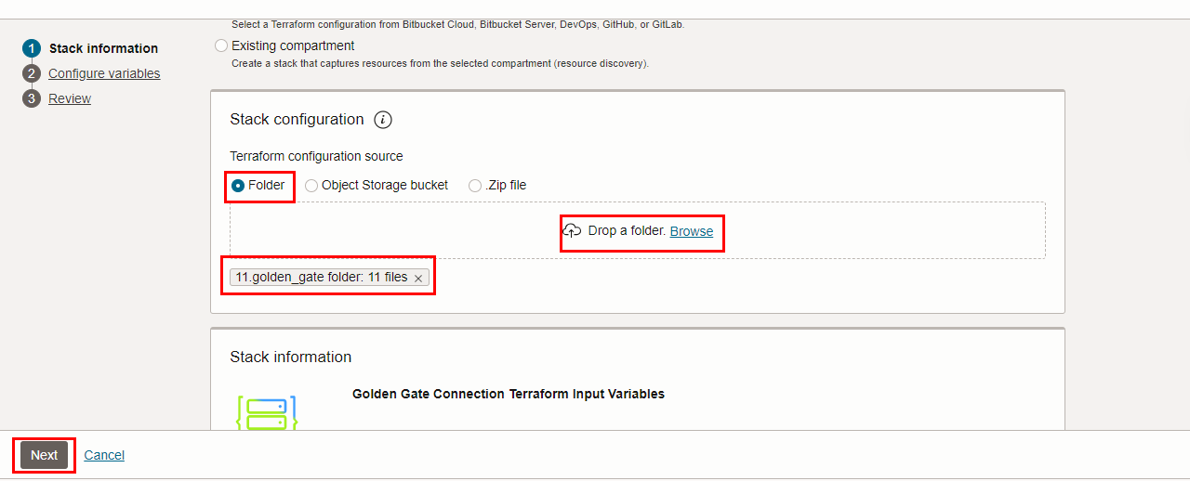

Select the parameters as per the below screen,
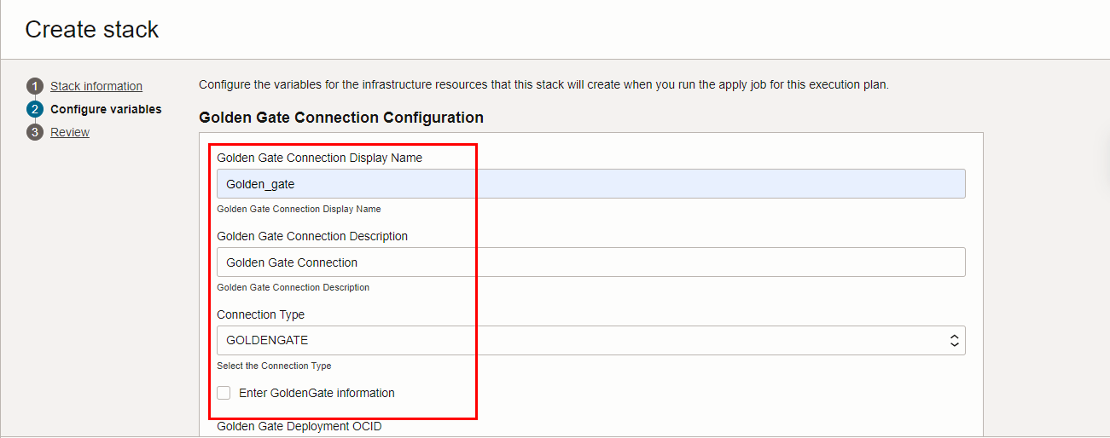

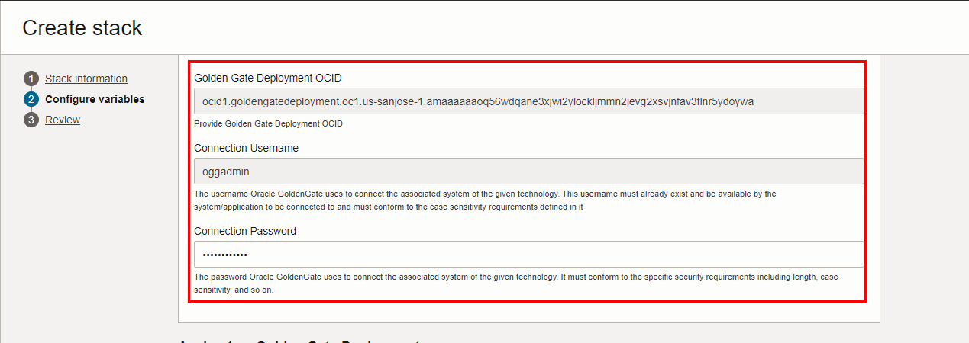

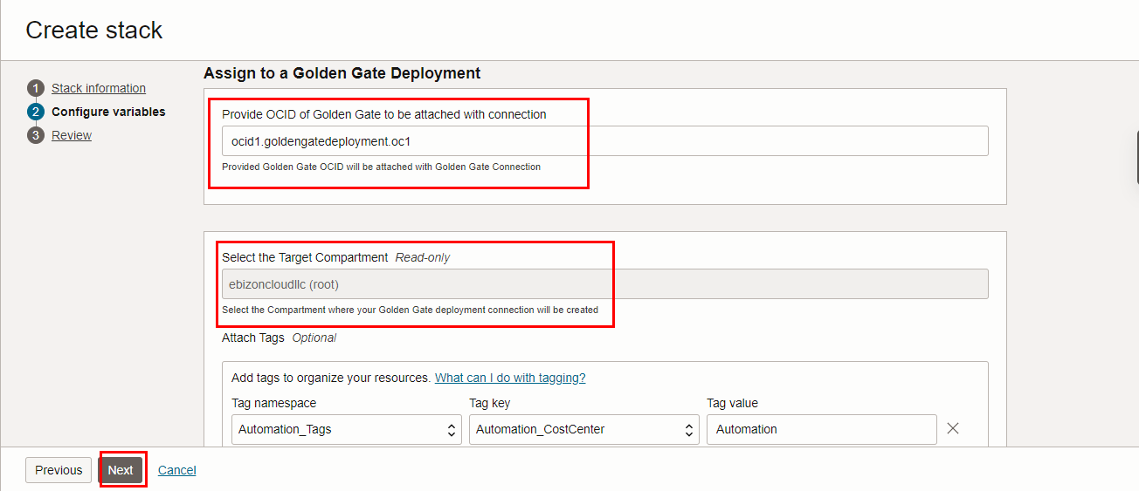
Click “NEXT”
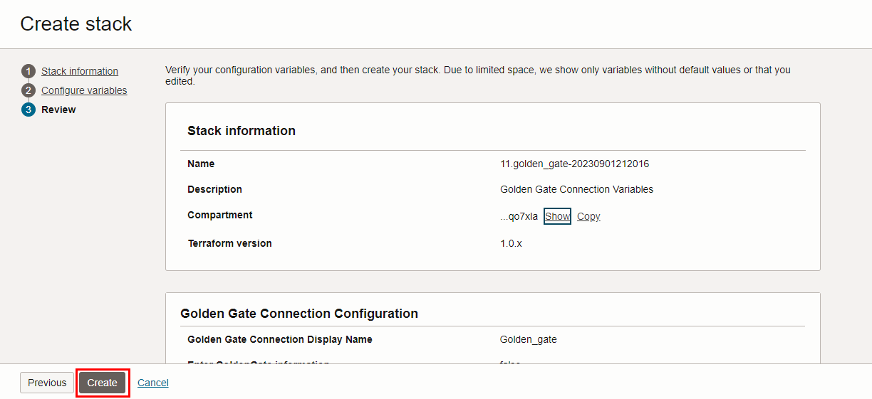
Click “CREATE”

Plan the Job
Click the “Plan”
